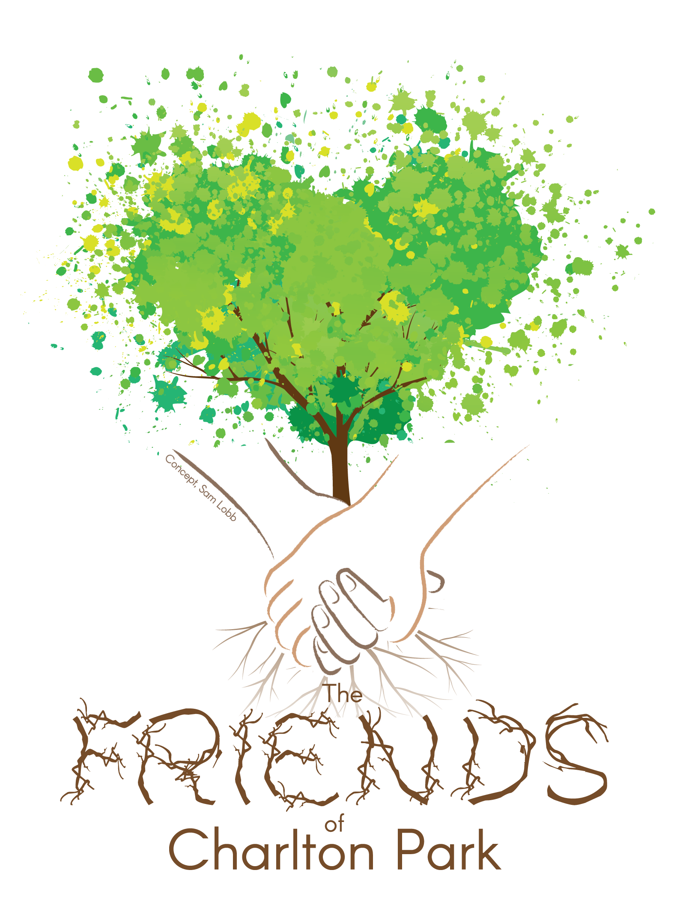

Friends of Charlton Park

Financial statements

for the year ended 30 November 2023

Page Contents
2 Committee members’ annual report
3 Receipts & payments account
4 Statement of assets & liabilities
5 Notes to the accounts

Friends of Charlton Park

Committee members’ annual report

for the year ended 30 November 2023

Main address
friendscharltonpark@gmail.com

Committee members
Liz Bennet Chair
Linda Bossac Secretary from June 23
Trisha Anderson Secretary till June 23
Annie Drewry Treasurer
Vicky Makepeace
Mike Chatterton

Bankers
National Westmister Bank PLC

Governance and management
Friends of Charlton Park is a constituted community group as part of the Greenwich wide Friends groups.

Aims and objectives
To work in partnership with the Royal Borough of Greenwich to:
- protect and enhance Charlton Park as a place of enjoyment and recreation for our local community
- help residents contribute to the management and development of Charlton Park to ensure that it best serves the needs of our community
- encourage the recreational use of the park by supporting/creating events and activities
- promote the cultural, educational, historical, environmental and biodiverse importance of the park by working in partnership with the community, the Council and other interested parties etc.

Summary of the main achievements during the period
Summary of the main achievements during the period

For teens: Beats, Boards and BBQ for ParkFest 2023

Despite the blustery winds, we had an amazing turnout at Beats, Boards & BBQ for Parksfest this July, a true testament to the spirit of Charlton. This great day out for everyone featured:

- Skateboarding & showcase: Skate lessons, dog agility, skateboarding for your dog
- Phat beats & local art: DJs on the decks, spoken word performance and street art
- BBQ & juice bar: Picnic on the grass with a feast by local favourites and free burgers for under 18s

Above all the event set out to engage teenagers from Charlton, collaborating with School of Skate on a skatejam and free lessons, and offering free burgers for under 18s. Visually, a glance at the crowd showed that we succeeded. Age and postcode data from the burger giveaway also demonstrated that 46% were between the ages of 11-18 and of those 55% lived in the most deprived neighbourhoods locally.

It was also a triumph for community collaboration, proudly bringing together Charlton’s local businesses - such as the Old Cottage Coffeeshop Cafe and the Village Greengrocers - as well as creative talent like DJ Shorty, spoken word poets and rappers.

Our community showed up in full force at Beats, Boards and BBQ, showcasing our unique blend of creativity, diversity, and just a bunch of really cool folks doing what they love.

The day in numbers:

- 900 attendees
- 19 organisations involved
- 23 volunteers helped out

For children: collaborated with the council on improvements to the playground

We are delighted to see the transformation this year of our local park's playground, which the council refurbished and expanded to include:

- A zip line!
- Natural timber trail with five new trees
- Wooden cableway and agility trail with balance posts
- Sensory zone with a new inclusive seesaw and toddler play tower
- Existing play equipment refurbished or replaced as needed

The playground now caters brilliantly to older children as well as younger ones. The imaginative play elements introduced have brought a new level of fun and inclusivity, making the space a vibrant hub for all our kids.

This project is a testament to the power of community voices, drawing on our 2021 park users survey that received over 200 responses. The adjustments made in response to our feedback demonstrate a genuine commitment from our councillors to not just listen, but to act on the views of those consulted.

The playground also received four new benches, some incorporating games like Snakes and Ladders and chess, and the four existing benches were moved into the same lovely area in the shade - making for a much better experience for playground users.

For everyone: further events from our calendar

RSPB Big Charlton Birdwatch
A staple of our year, this event brightens every January by encouraging people to get out and spot birds in Charlton Park - engaging kids by offering children's binoculars and bird books available to borrow. The results help the RSBP build a picture of Britain’s bird life.

Meadow volunteer day
We brought together volunteers with rakes to maintain the ecology of Charlton Park’s meadow area by clearing grass cuttings in accordance with the ecological management plan for the site. The council also installed a dedicated sign board for the meadow, which we now use to engage all passers by with information about the biodiversity benefits of the project.

CABAHS Plant Sale and Community Day
We joined Charlton and Blackheath Amateur Horticultural Society for their spring community. Our stall provided the opportunity to identify wildflower plants plucked judiciously from Charlton Park’s own meadow, showcasing the biodiversity being created here.

For the park: consulted on key decisions

Throughout the year, we have engaged with the council on key decisions around the park. Most notably, we offered feedback on the new artificial cricket pitch and hosted productive conversations with the cricket provider and council representatives on how best to manage booking and ensure maximum use of this new facility.

Signed on behalf of the committee:

Signed _____________________________________________ Date __________
Name, Chair

Friends of Charlton Park

Receipts & payments account

for the year ended 30 Novemember 2023

£
Receipts
Grants 3800
Donations 0
Memberships 0
Bank interest 0
Other receipts 0
Total receipts 3800

Payments
Parksfest 4226.12
Volunteer expenses 0
Equipment 0
Activities 0
Insurance 0
Other payments 0
Total Payments 0

Net receipts/(payments) (426.14)

Bank and cash at the start of the period 1559.09

Bank and cash at the end of the period 1052.95

Friends of Charlton Park

Statement of assets and liabilities

at 30 November 2023

£
Cash assets
Current account 1052.95
Deposit account 0
Petty cash 0
Total cash assets 1052.95

Greenwich Parksfest Reconciliation Payment £300

Other assets
Birdwatching equipment £0.00
Gardening equipment £0.00

Liabilities
URL payment to Stuart Hopper £14.45

These financial statements are accepted on behalf of the organisation by:

Signed ___________________________________ Dated ___________
Name, Treasurer

Friends of Charlton Park

Notes to the accounts

for the year ended 30 November 2023

- Receipts & payments accounts
All movement in funds this year has been on the delivery of Beats, Boards and BBQ as part of Parksfest, the final £300 payment for the project will be released on the final monitoring report to be submitted to RBG from the overall Parksfest organisers of which we have submitted our evaluation.

After reconciliation of grants and payments it is anticipated that Beats, Boards and BBQ event will incur a £71 loss.

- Grants & Donations

£
Grants and donations
Ward Budget 2400
Parksfest 1700
Total grants and donations 4100

- Committee members’ remuneration
During this period, a total of £210.43 was reimbursed to one committee member for printing and production costs for Beats, Boards and BBQ. NB Friends of Charlton Park Treasurer received an account debit card in July 2023 and will be able to make direct payments in future.

